Here's how all 9 devices could work together in a network:
- Hosts (Client and Server):
  - Clients (e.g., computers or printers) connect to the network to access resources like files or databases hosted by servers (e.g., a web server, file server).
- Repeaters:
  - If the network is large or covers a wide area, repeaters are used to amplify weak signals, ensuring strong network connections across long distances (e.g., within a large office building).
- Hubs:
  - In smaller networks (e.g., home or small office), hubs can be used as a central point to connect multiple devices like computers and printers, although they are less efficient than newer devices.
- Bridges:
  - To manage traffic in larger networks, bridges divide a LAN into smaller segments (e.g., separating different departments in an office). This reduces collisions and traffic congestion, while still allowing communication between segments.
- Switches:
  - Switches are used to connect devices efficiently within a LAN, providing each device with dedicated bandwidth. They help to reduce network collisions, especially in busy environments like a university campus.
- Routers:
  - A router connects the LAN to external networks (such as the internet) and manages traffic between them, ensuring that data is routed efficiently to its destination.
- Gateways:
  - If the network needs to communicate with another network that uses a different protocol (e.g., an IBM mainframe system), a gateway is used to translate the protocols, enabling communication between incompatible networks.
- Segmentation:
  - Segmentation using devices like bridges, switches, or routers helps reduce network traffic and collisions by creating smaller collision domains, improving overall network performance.
- Switching Modes:
  - Switching modes like cut-through mode in switches can be used in scenarios where low latency is crucial, such as in high-speed trading or time-sensitive applications. This mode allows data to be forwarded as soon as the destination address is read, rather than waiting for the entire packet to arrive.

Example of a Network:
In a corporate office:
- Clients (employees’ computers) access files from a file server.
- Repeaters are used in larger buildings to extend the signal.
- A hub might connect a few old devices in a small part of the office.
- Bridges separate traffic between different departments (e.g., HR and Sales).
- Switches manage data traffic between devices, ensuring smooth communication.
- Routers connect the office LAN to the internet and route data to other remote offices.
- Gateways connect the Ethernet network to a mainframe system using a different protocol.
- Segmentation ensures that high-traffic departments are separated to improve performance.
- Switching modes like cut-through are used for low-latency applications, ensuring quick data delivery.
This approach ensures a well-organized, efficient network that handles high traffic and provides reliable communication.

1. LAN (Local Area Network)
- Definition: A network covering a small geographic area, such as a home, office, or campus.
- Devices Used:
  - Hosts: Computers, printers, servers.
  - Switches: To connect devices efficiently within the LAN.
  - Hubs: For basic connections (less common today).
  - Routers: To connect the LAN to external networks like the internet.
  - Access Points (APs): For wireless connections.
- How Devices Are Connected:
  - Devices like computers and printers are connected to switches via Ethernet cables or Wi-Fi.
  - Switches connect all devices and manage data traffic within the network.
  - Routers connect the LAN to the internet or other networks.
  - Access Points provide wireless access for mobile devices.

2. WLAN (Wireless Local Area Network)
- Definition: A LAN that uses wireless communication (Wi-Fi) to connect devices.
- Devices Used:
  - Hosts: Computers, smartphones, tablets.
  - Wireless Access Points (APs): Provide wireless connectivity.
  - Routers: Connect the WLAN to external networks.
  - Repeaters: Extend the range of the WLAN by amplifying signals.
- How Devices Are Connected:
  - Devices (e.g., smartphones, laptops) connect wirelessly to Access Points.
  - The Access Points communicate with the router to provide internet access.
  - Repeaters may be used in larger areas to extend the coverage.

3. MAN (Metropolitan Area Network)
- Definition: A network that covers a city or a large campus, connecting multiple LANs.
- Devices Used:
  - Routers: To connect different LANs and direct traffic between them.
  - Switches: Manage traffic within each LAN segment.
  - Bridges: To segment the network and reduce traffic.
  - Fiber Optic Cables: To provide high-speed connections across large distances.
- How Devices Are Connected:
  - Routers connect LANs within the city to create the MAN.
  - Switches handle traffic within each LAN segment.
  - Fiber optics connect different areas and networks in the city.
  - Bridges segment traffic to avoid congestion.

4. WAN (Wide Area Network)
- Definition: A network that covers a broad geographical area, such as a country or the entire world (e.g., the internet).
- Devices Used:
  - Routers: Direct traffic between networks across large distances.
  - Modems: Connect homes or offices to the internet over telephone lines or cable.
  - Gateways: Connect different networks, often using different protocols.
  - Switches: Manage traffic within large data centers or regional hubs.
  - Repeaters: Amplify signals over long distances.
- How Devices Are Connected:
  - Routers are used to direct traffic across vast distances, connecting LANs to the WAN.
  - Modems and Gateways provide access to the internet or other wide-area networks.
  - Repeaters and Switches ensure that data can travel long distances without loss of quality.

5. PAN (Personal Area Network)
- Definition: A small network typically within a range of a few meters, connecting personal devices like phones, laptops, and smartwatches.
- Devices Used:
  - Smartphones: Used to connect to other devices in the PAN.
  - Bluetooth or Wi-Fi Adapters: Allow wireless connections between devices.
  - Laptops, Tablets, and Smartwatches: Can connect wirelessly to other devices.
- How Devices Are Connected:
  - Devices connect to each other directly (e.g., via Bluetooth or Wi-Fi).
  - A smartphone might connect wirelessly to a laptop and a smartwatch, forming a small PAN.

6. CAN (Campus Area Network)
- Definition: A network that spans multiple buildings within a campus (e.g., a university or a business park).
- Devices Used:
  - Routers: To connect different buildings or areas within the campus.
  - Switches: Used in each building to manage traffic between devices.
  - Fiber Optic Cables: For high-speed connectivity between buildings.
  - Wireless Access Points (APs): Provide wireless access in the campus.
- How Devices Are Connected:
  - Routers connect LANs in different buildings.
  - Switches manage data traffic within individual buildings.
  - Fiber optics connect buildings at high speed.

Summary Table
Network Type | Devices Used | How They're Connected
LAN | Hosts, Switches, Routers, Access Points | Wired or wireless connections; routers connect to external networks.
WLAN | Hosts, Access Points, Routers, Repeaters | Wireless devices connect to access points, routers connect to external networks.
MAN | Routers, Switches, Bridges, Fiber Optics | Routers connect LANs across a city, switches manage traffic, fiber optics connect regions.
WAN | Routers, Modems, Gateways, Switches, Repeaters | Routers and modems connect local networks to the WAN, gateways translate protocols.
PAN | Smartphones, Bluetooth/Wi-Fi Adapters, Laptops | Devices connect wirelessly over short distances (Bluetooth, Wi-Fi).
CAN | Routers, Switches, Fiber Optics, Access Points | Routers connect buildings, switches manage local traffic, fiber optics provide high-speed links.
These devices work together to ensure seamless communication, data transfer, and resource sharing across different network types.

1. LAN (Local Area Network)
- Host Devices (e.g., Computers, Printers): These are the end devices that generate or receive data.
- Switch: Hosts connect to a switch, which acts as the central point for data exchange within the network.
- Router: If the LAN needs to connect to an external network (e.g., the internet), the router is used to route data between the LAN and the external network.
- Access Point (Optional): For wireless connections, devices communicate with Access Points, which then connect to the switch or router.
Order:
- Hosts → Switch → Router → Internet (optional)

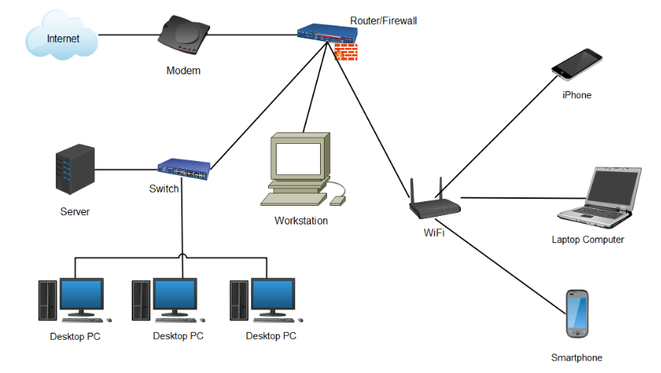
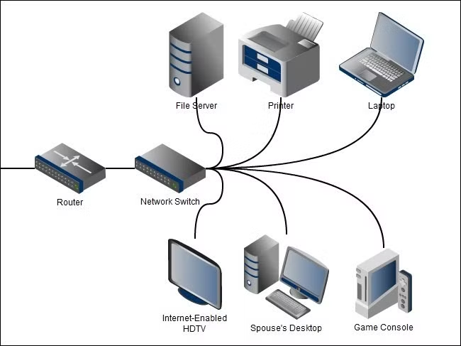

2. WLAN (Wireless Local Area Network)
- Host Devices (e.g., Laptops, Smartphones): These devices generate or receive data.
- Wireless Access Points (APs): Host devices connect wirelessly to Access Points for data transmission.
- Router: The Access Points are connected to a router for routing the traffic to the wider internet or other networks.
- Repeaters (Optional): If the wireless signal needs to be extended to cover a larger area, repeaters amplify the signal.
Order:
- Hosts → Access Points → Router → Internet (optional) → Repeaters (optional)

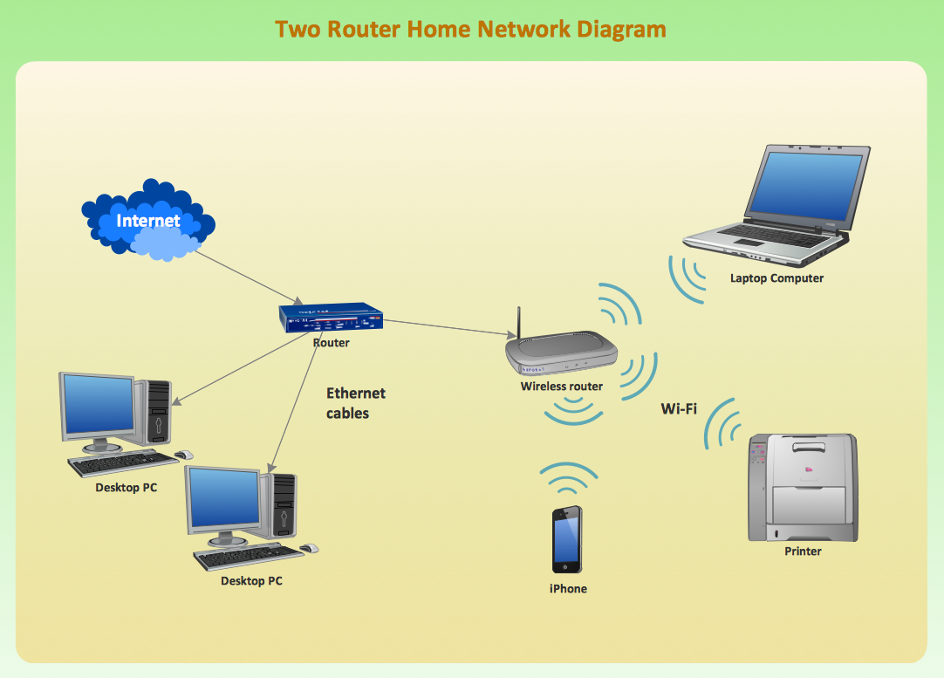
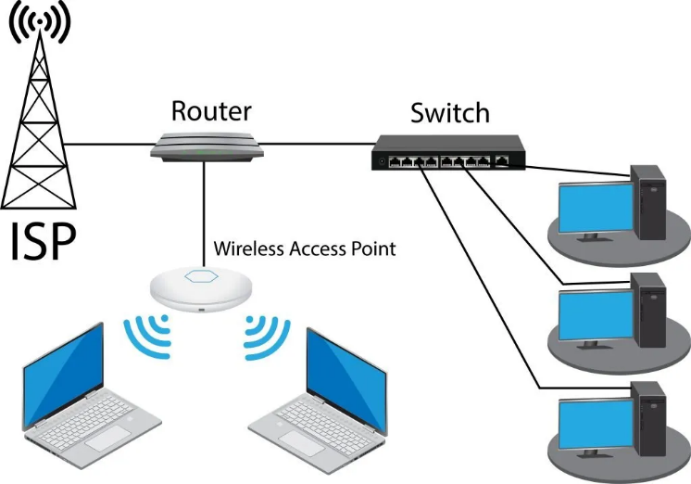

3. MAN (Metropolitan Area Network)
- LAN Devices (Hosts, Switches, Routers): Multiple LANs within a city are connected together to form the MAN.
- Router: Routers connect the different LANs (at various locations) to create the MAN.
- Switches: Used within each LAN in the MAN to manage local traffic and connect devices.
- Fiber Optic Cables: High-speed fiber optics may connect various LANs and routers to form the backbone of the MAN.
- Bridges (Optional): If needed, bridges can be used to divide the MAN into smaller segments to reduce traffic congestion.
Order:
- LAN Devices → Switches → Routers → Fiber Optics → MAN Backbone → Bridges (optional)

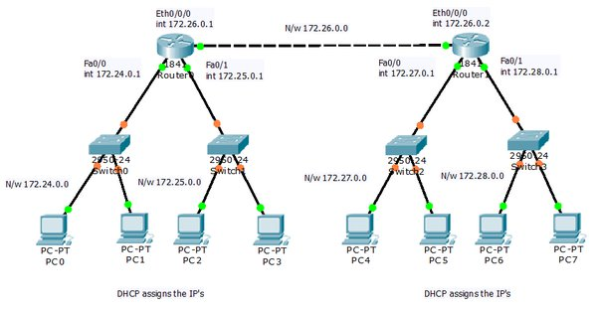

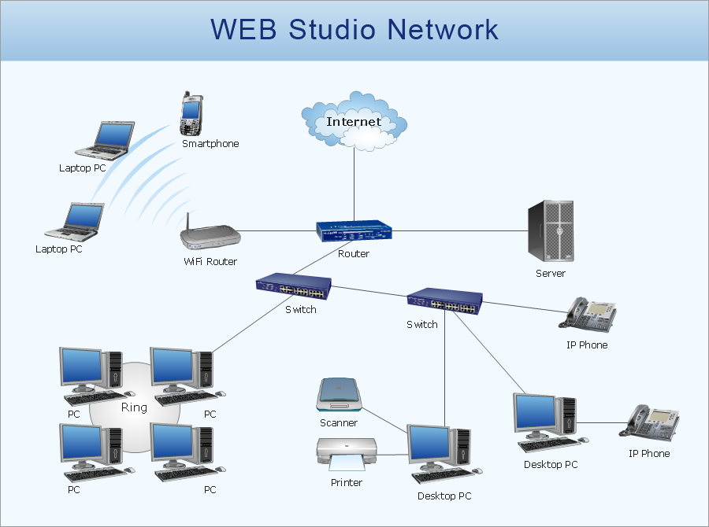

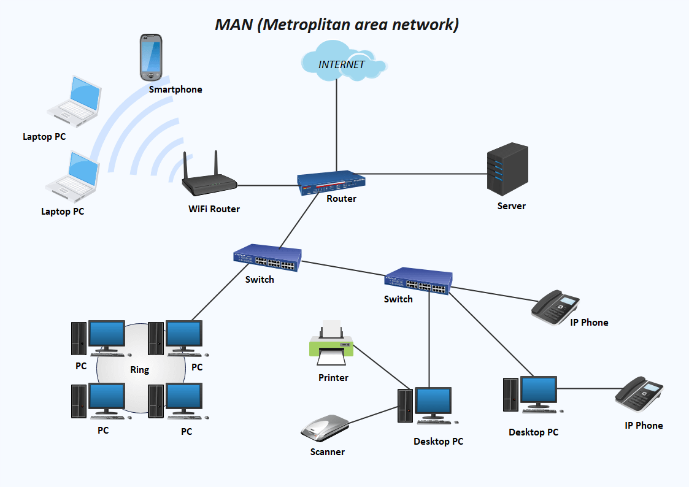

4. WAN (Wide Area Network)
- Router: Devices in a LAN or MAN are connected to the WAN using routers.
- Modem: For home or office connections, the modem provides connectivity to the WAN (such as via DSL, cable, or fiber).
- Gateway: If the WAN needs to connect to different types of networks (e.g., connecting an Ethernet network to a mainframe system), gateways are used to translate protocols.
- Switches: In large data centers or regional hubs, switches are used to manage internal traffic.
- Repeaters (Optional): In remote areas, repeaters may be used to extend signal strength over long distances.
Order:
- LAN/MAN Devices → Router → Modem → WAN → Gateways (optional) → Repeaters (optional)

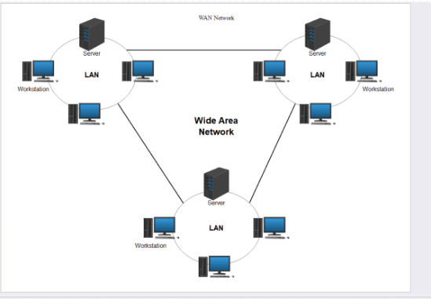

5. PAN (Personal Area Network)
- Host Devices (e.g., Smartphones, Laptops): These are the primary devices in a PAN.
- Bluetooth/Wi-Fi Adapters: Host devices communicate using Bluetooth or Wi-Fi adapters for short-range wireless communication.
- Router (Optional): If the PAN needs to access the internet or other networks, the devices can connect to a router.
Order:
- Host Devices → Bluetooth/Wi-Fi Adapters → Router (optional) → Internet (optional)
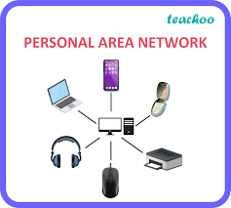

6. CAN (Campus Area Network)
- LAN Devices (Hosts, Switches): Multiple LANs within a campus (e.g., a university or business park) form a CAN.
- Router: Routers connect the different LANs across the campus and manage traffic between them.
- Switches: Each individual LAN in the CAN uses switches to manage local traffic.
- Fiber Optics: Fiber optics connect the different buildings or sections of the campus at high speeds.
- Access Points (Optional): For wireless connectivity, access points are deployed across the campus.
Order:
- LAN Devices → Switches → Routers → Fiber Optics → CAN Backbone → Access Points (optional)

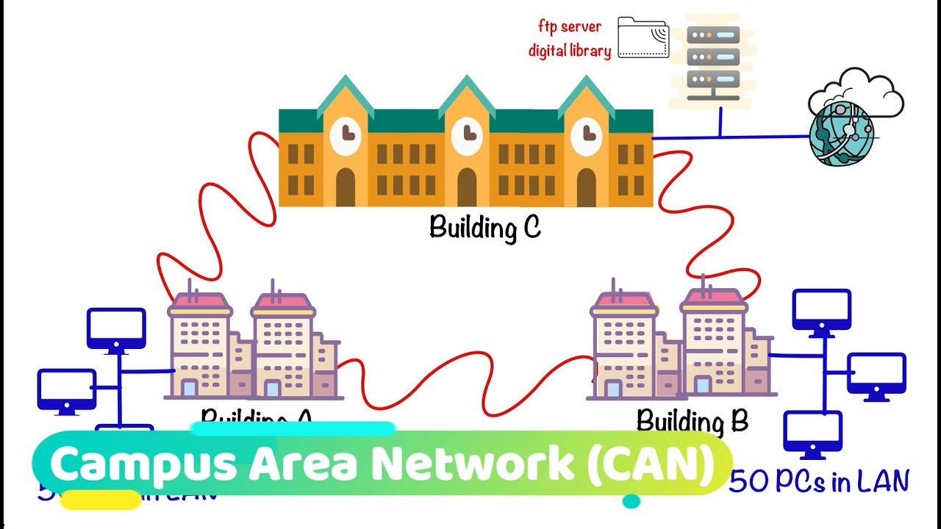

General Device Flow Across Networks
Network Type | Device Flow Order
LAN | Hosts → Switch → Router → Internet (optional)
WLAN | Hosts → Access Points → Router → Internet (optional) → Repeaters (optional)
MAN | LAN Devices → Switches → Routers → Fiber Optics → MAN Backbone → Bridges (optional)
WAN | LAN/MAN Devices → Router → Modem → WAN → Gateways (optional) → Repeaters (optional)
PAN | Host Devices → Bluetooth/Wi-Fi Adapters → Router (optional) → Internet (optional)
CAN | LAN Devices → Switches → Routers → Fiber Optics → CAN Backbone → Access Points (optional)
This flow shows how each device connects and how the data is routed or managed in each network type.

